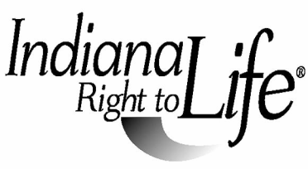

2021 State Oratory Contest Application

Contestant Name __________________________________________________

Year in School ____________________________________________________

Street Address____________________________________________________

City_________________________________________ Zip _________________

Phone_______________________________ Cell/Other_____________________

E-Mail Address ____________________________________________________

Parent or Guardian Name____________________________________________

RTL Affiliate_______________________________________________________

Local Oratory Contest Coordinator_________________________________________

Phone________________________ Cell or Home__________________________

E-mail__________________________________________________________

Please email (SINGLE pdf or jpg formatted file) application and a copy of the student’s speech no later than May 10, 2021 to:

Indiana Right to Life
Re: 2021 Oratory Contest
1906 Hamilton Blvd.
Winona Lake, IN 46590
davekoontz@protectinglife.com

