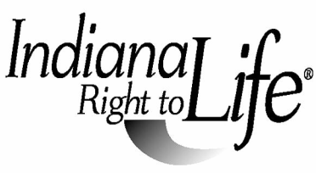

2022 State Oratory Contest Application

Contestant Name __________________________________________________

Year in School ____________________________________________________

Street Address____________________________________________________

City_________________________________________ Zip _________________

Phone_______________________________ Cell/Other_____________________

E-Mail Address ____________________________________________________

Parent or Guardian Name____________________________________________

RTL Affiliate_______________________________________________________

Local Oratory Contest Coordinator_________________________________________

Phone________________________ Cell or Home__________________________

E-mail__________________________________________________________

Please email (SINGLE pdf or jpg formatted file) application and a copy of the student’s speech no later than April 27, 2022 to:

Indiana Right to Life
Re: 2022 Oratory Contest
522 Gipper Way West
Suite L
Avon, IN 46123
mwilliams@irtl.org

